# Stock Screener Project Plan

Contributors: Art Fogiel, Kathleen Connell, Michael Harrison

Division of labor: Leveraging the Model View View-Model design pattern, the roles are divided evenly between the three contributors.

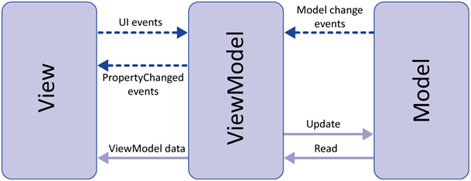

Art Fogiel: Project Manager, Views

Michael Harrison: View Model, Testing

Kathleen Connell: Model, Documentation

Timelines:

Test Plan Due Date: 1/28/18 – Complete test plan to be executed on the software

Project Design Due Date: 2/4/18 – Complete design and class diagrams for the software

Phase 1 Due Date: 2/11/18 – Initial solution setup and flow between classes

Phase 2 Due Date: 2/18/18- Class implementations and UI

Phase 3 Due Date: 2/25/18 – Complete classes and stock retrievals from web

Final Submission Due Date: 3/4/18 – Final report, debugging, testing